Thinking about returning to school
These are uncertain times and can be stressful for both adults and children.
There is less than a month now until we all return to school. It has been a while since your child has attended school, some children may be really excited and are looking forward to returning to school.
Other children may be anxious and worried
It is therefore very important that you prepare your child to get ready for return, by talking to him/her.
Introduce returning.
Find out how they feel about this

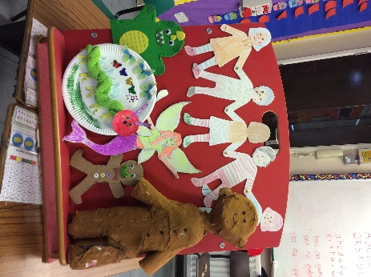
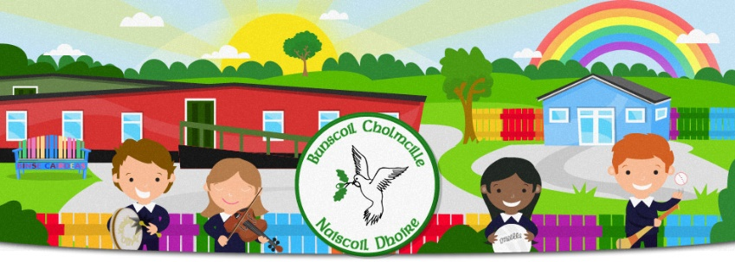
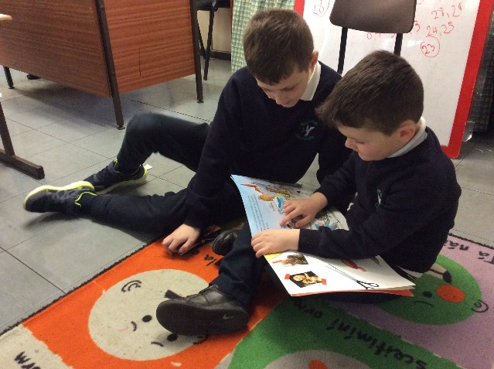
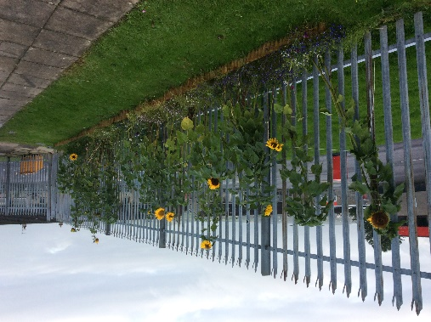
Fáilte ar ais
Welcome back
We all look forward to seeing your child back at school next month. Sunflowers, apple and plum and other types of trees have been planted since you left. You can help us look after them as they grow.
We also look forward to pumpkins growing again, hopefully our sunflowers will grow like they did last year. Other flowers have also been planted. I wonder what they are!
We also have a geodesic dome at the back of the school. We will be able to plant and do some work in here when the weather is not great.
We look forward to getting started.

Ag tacú le do pháiste
pilleadh ar scoil
Supporting your child’s return to school

What your child may be anxious about?
- have become used to being at home for months with very little interaction maybe with other children.
- Used to doing their own thing
- Doing things with parents/siblings only
- Mixing with people again
- What school will be like
These feelings are perfectly normal. It is important to emphasise this to your child.

What are they looking forward to?
While acknowledging there may be worries, focus on the positive;
- Meeting friends again
- Playing in the yard
- Doing different activities
- Helping in the garden
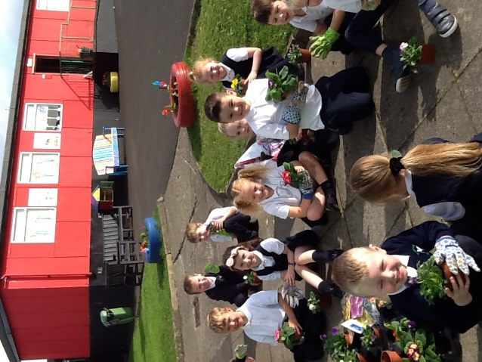
As we get closer to return time, increase the number of times going to school is mentioned.

Things to do:
- Begin to establish a morning and bedtime routine
- Read to your child
- Have a look at the school uniform
- Maybe take a drive past the school
- Have ‘am sosa’ round eleven as they would at school
- If your child takes their own lunch, get your child to help prepare it.

