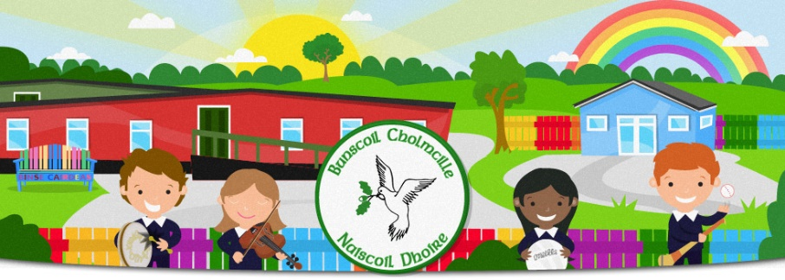
FÁILTE GO RANG 2 / WELCOME TO RANG 2
Bunscoil Cholmcille & Naíscoil Dhoire
40A Bóthar Bhaile Stíl
Doire
BT48 8EX
02871359648
www.bunscoilcholmcille.com
info@gaeloid.doire.ni.sch.uk
A Thuismitheoir/choimeadaí, a chara,
We are all looking forward to welcoming your child back to school to Rang 2. We have planned to bring the children in as groups to allow them time to settle and to meet the teacher and their friends again.
Please also read the general information on the school website about returning to school. One adult may walk the child to the classroom where he/she will be met by Múinteoir Caroline.
Class Teacher: Múinteoir Caroline Mhic Colla
Rang 2 Groups (grúpaí) - 2020/2021
Grúpa 1- 24-25 August  (not in 26-27 August) | Grúpa 2 26-27 August | Grúpa 1 & 2 - 28 August
Donal  Jack  Noah  Pearse Mc Grory  Faye  Sophia  Nevaeh | Milo  Pearse Melarkey Deane  Olivia  Seán óg  Oisín  Alicia  Eimear | All children in attendance.

Dátaí: Am Tosaithe & Críochnaithe
Dates: Start & Finish Times

For the week 24-28 August, children will finish at 12.00.
Full time attendance begins on Tuesday, 1 September from staggered times and will finish at 2.00.

Arriving & Departing
Below is arrival and departure times for families, all other children arrival at 8.55 and hometime 12.30.
Sloinnte/Surnames for families | Arrival | Home Time
A - E | 8.55 | 12.00
F - K | 9.05 | 12.10
L – M (M, Mc, Mac) | 9.20 | 12.20
N-Z | 9.30 | 12.30

Ag pilleadh ar scoil / Returning to school
- All pupils should wear school uniform and bring a coat (clearly labelled with your child’s name.
- Ensure your child wears shoes with velcro fastening.
- It is also important that the uniform is kept clean. It may be good practice from the beginning for your child to change out of their uniform when they go home each day.
- Lunch boxes and a water bottle should be brought each day (please ensure regular cleaning).
- School will provide individual stationery supplies and individual folders to store books, pens etc
- Pupils should not bring a school bag at this time.
- No other personal items should be sent to school with your child(ren).
- Break times for all pupils will be staggered and children will remain in their ‘protective bubbles’ during these breaks.
- Monday 31st August is a bank holiday and school will be closed.

- We will be sending a short questionnaire shortly about how your child coped during COVID 19. This will help us plan any support your child may need.

