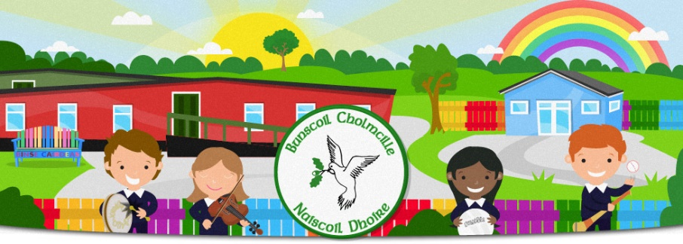
FÁILTE GO RANG 1 / WELCOME TO RANG 1
Bunscoil Cholmcille & Naíscoil Dhoire
40A Bóthar Bhaile Stíl
Doire
BT48 8EX
02871359648
www.bunscoilcholmcille.com
info@gaeloid.doire.ni.sch.uk
A Thuismitheoir/choimeadaí, a chara,
We are all looking forward to welcoming your child to Rang 1. We bring the children in as small groups to allow them time to settle and to meet the teacher and to also get to know the other children especially children who may not have attended Naíscoil Dhoire. Please also read the general information on the school website about returning to school. One adult may walk the child to the classroom. If necessary, an adult may stay in class with the child for a time if he/she is unsettled.
Class Teacher: Múinteoir Clíona Nic Cionnaith
Rang 1 Groups (grúpaí) - 2020/2021
Grúpa 1- 24-25 August | Grúpa 2 26-27 August  (Group 1&2) | Grúpa 3 - 28 August  (Grúpa 1,2 &3)
Charlie  Róise  Cadhlá  Cillian  Layla  Iarlaith | Finbarr  Anthony  Lukas  Sarah  Olivia  Lily | Catháin  Cassie  Jessica  Liam  Aodhán  Oscar  Valentina

Dátaí: Am Tosaithe & Críochnaithe
Dates: Start & Finish Times

24 August - 11 September, 9.30 - 12.00.

14-18 September, children receive lunch and finish at 1.00.

From 21 September, Normal start time between 8.55-9.05

Normal Finish times. Children can be collected between 1.50-2.00.

Ag pilleadh ar scoil / Returning to school
- All pupils should wear school uniform and bring a coat (clearly labelled with your child’s name.
- Ensure your child wears shoes with velcro fastening.
- It is also important that the uniform is kept clean. It may be good practice from the beginning for your child to change out of their uniform when they go home each day.
- Lunch boxes and a water bottle should be brought each day (please ensure regular cleaning).
- School will provide individual stationery supplies and individual folders to store books, pens etc
- Pupils should not bring a school bag at this time.
- No other personal items should be sent to school with your child(ren).
- Break times for all pupils will be staggered and children will remain in their ‘protective bubbles’ during these breaks.
- Monday 31st August is a bank holiday and school will be closed.

- We will be sending a short questionnaire shortly about how your child coped during COVID 19. This will help us plan any support your child may need.

