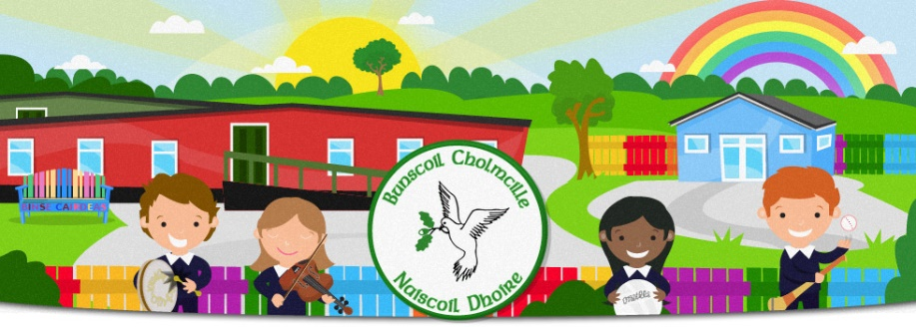
Bunscoil Cholmcille & Naíscoil Dhoire
40A Bóthar Bhaile Stíl
Doire
BT48 8EX
www.bunscoilcholmcille.com
infor@gaeloid.doire.ni.sch.uk
028 71359648
A thuismitheoir.choimeadaí, a chara,
As you know, your child will be receiving two very important sacraments in the next two weeks.
First Confessions
First Confessions will take place in our Lady of Lourdes, Steelstown on Thursday, 10 September at 2.00. I will bring the children to the chapel for 2.00pm and they will sit in their allocated pew with their parents. Only 2/3 adults are allowed to accompany their child for First Confession.

An Chéad Chomaoineach / First Holy Communion
Your child’s First Holy Communion will take place in Our Lady of Lourdes Chapel in Steelstown on Friday, 18 September at 2.00pm.
We hope that this will be a joyous celebration for your family but we still have to adhere to certain restrictions as we do our best to keep everyone safe.
- Each family will be allocated a pew in the chapel. Your child’s name will be at the end of the pew
- Up to seven members from each family are permitted to attend the ceremony
- Your child will sit with you in the chapel
- One family at a time will walk to the alter to receive holy communion
- Communion will be received in the hand only
- Unfortunately, a choir or singing by the congregation is not permitted but we will have a soloist/musical instrument during the mass
- A photographer will be in school on Monday morning after the First Communion to take photographs. The children may come to school dressed in their communion clothes and can change afterwards if they wish.

The children have been busy preparing for this special sacrament in class for the past few weeks. They are looking forward to this day and we look forward to celebrating with them.

Le meas
Máire Mhic Lochlainn

