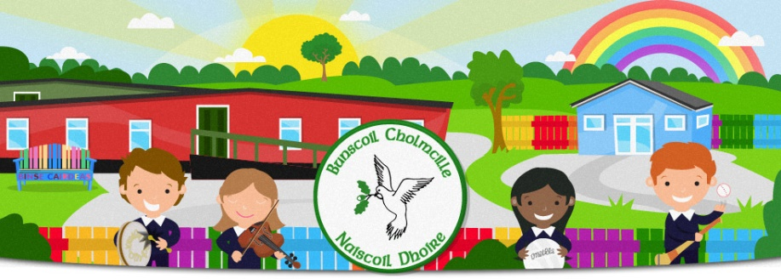
Bunscoil Cholmcille & Naíscoil Dhoire
40A Bóthar Bhaile Stíle
Doire
BT48 8EX
www.bunscoilcholmcille.com
info@gaeloid.doire.ni.sch.uk
028 71359648
A thuismitheoir/choimeadaí, a chara,

A number of enquiries have been received regarding our arrangements for next week. There are genuine concerns if there was a case in a class next week, a child and their whole family could potentially be self-isolating up until the 1 January. We realise Christmas is a special time for children so this is not a scenario which children, families or staff would like to find themselves in.
School will remain open until the 18 December as planned. After a discussion with the Chairperson of the Governors and staff, we have also agreed that any parent wishing to keep their child at home next week may do so but will be marked PRESENT at school. A work pack of the work that will be ongoing in class will be sent home this Friday. This will mainly be Maths, Literacy and Art around the theme of Christmas. The teachers will remain in contact with anyone at home next week.
Due to this, our Christmas raffle will now take place this Friday at 11.00.
While the children are watching the panto Beauty and the Beast this Thursday, they will also have their Christmas party.
We look forward to seeing them in their Christmas jumpers tomorrow and while we will not be holding our Christmas service in the chapel, all classes have been very busy with Christmas preparations.
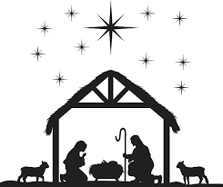
My priority is the health and safety of all of your children and will continue to be so. Despite this being an extremely anxious and stressful time, we all hope you and your family have a safe, peaceful and happy Christmas.

Le meas
Máire Mhic Lochlainn
Príomhoide

