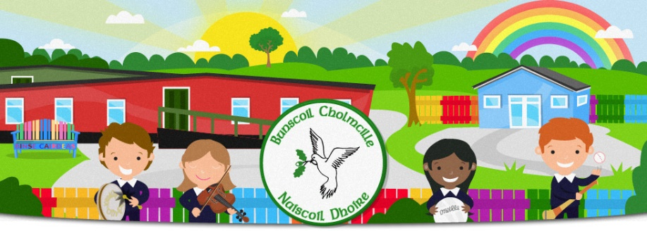
Bunscoil Cholmcille & Naíscoil Dhoire
40A Bóthar Bhaile Stíl
Doire
BT48 8EX
www.bunscoilcholmcille.com
infor@gaeloid.doire.ni.sch.uk
028 71359648
Lúnasa/August 2021
A Thuismitheoir/Choimeadaí, a chara,
Tá súil agam go raibh sos breá agaibh uilig, tá muid ag an phointe go bhfuil muid uilig ag pleanáil le bheith ag filleadh ar scoil.
I hope you all had a lovely break, we are at the point where we are all planning to return to school. All the staff are looking forward to seeing the children return on the 1 September and we keep our fingers crossed that it will be a more settled school year than the previous two have been.
I know you are all waiting anxiously to hear who will be teaching your child in the next school year, this is nearly finalised but we are awaiting a final confirmation from the authorities about approvals, we will let you know next week who will be your child’s class teacher in the incoming school year.
Múinteoir Caroline is taking a career break for the schoolyear 2021/22. As you know, Múinteoir Róisín Mhic Giolla Bhuí is now a permanent member of staff and will be returning from maternity leave after Christmas. Múinteoir Nuala is on maternity leave from the Naíscoil. Múinteoir Clíona Nic Cionnaith and Múinteoir Conchúr Mac Diarmada who were with us in the previous school year are returning to the teaching staff for the current school year. Múinteoir Gráinne Ní Ghaillín who has considerable teaching experience is also appointed to the teaching staff for this school year.

In order for us all to make a good start to the new school year, please keep the following pointers in mind.
Éide Scoile/School Uniform
No child likes to feel different, so wearing a school uniform gives a sense of belonging and security. Please ensure that your child is dressed in the full school uniform.
Girls Uniform
Navy skirt/trousers
White Polo shirt, Naíscoil-Light Blue polo shirt
Navy Jumper with Bunscoil Cholmcille crest
Black/Navy Shoes
Boys Uniform
Navy Trousers
White Polo Shirt, Naíscoil-Light Blue polo shirt
Navy Jumper with Bunscoil Cholmcille crest
Black Shoes

Tracksuit bottoms, jeans, are not acceptable.

False nails/nail varnish is not acceptable

Pupils can wear runners/plimsolls for PE
If you have jumpers with the old school logo, it is fine to wear those.
Start and finish times
It will be as important as before that parents/carers do not congregate at the school gates. A social distance of 2metres is to be maintained along with wearing a face mask. All children from Rang 3 upwards can walk to the classroom themselves, parents of Naíscoil, Rang 1, Rang 2 and vulnerable children may accompany their child to the classroom door. If you do so, please do not stay in the porch between classes as the space is small. For those parents accompanying their child to the classroom please enter via the path and exit through the playground gate. Parents can park in Steelstown chapel carpark and walk across to avoid too many cars at the school at the one time.
Naíscoil Dhoire: 8.55 – 1.25 (when in for a full day)
Rang 1 and Rang 2: 8.55 – 2.00 (when in for a full day)
Rang 3: 8.55 – 2.35
Rang 4-7: 8.55 – 2.50
We welcome our new pupils to Naíscoil Dhoire and Rang 1, they will begin on a staggered basis as is normal to allow them time to settle into school life.

Packs
Each child will have their own pack in school consisting of a pencil, eraser, sharpener, colouring pencil, scissor, pritt stick etc. This is to avoid sharing utensils during activities. Your child should also have a similar pack at home that they can use when completing homeworks etc when it begins.

Sos/Break time
We always aim to promote healthy eating at break and dinnertimes. Breaks should therefore consist of a piece of fruit and a drink of water/milk. We will send information soon about the milk and sos scheme.
We are unsure yet how dinnertimes are operating this year but we will update you when this is agreed.

Rang 5 will be receiving the sacrament of First Holy Communion on Wednesday, 15 September.

COVID related guidance arrived from the Department of Education yesterday, we will forward any new information next week. Hand and respiratory hygiene will be as important as ever. Tissues will be provided in school but you should also provide your child with a pack that they can keep in their bag. Please remind your child about these as they prepare to return to school.
The most important thing is that pupils will be beginning the new term on Wednesday, 1 September.
Enjoy the last weeks of the holidays.

Máire Mhic Lochlainn
Príomhoide

Start and finish times
Naíscoil Dhoire: 8.55 – 1.25
Rang 1 and Rang 2: 8.55 – 2.00
Rang 3: 8.55 – 2.35
Rang 4-7: 8.55 – 2.50
Rang 5 will be receiving the sacrament of First Holy Communion on Wednesday, 15 September.
We will forward further guidance when we receive it from the Department of Education but all pupils will be beginning the new term on Wednesday, 1 September.
We welcome our new pupils to Naíscoil Dhoire and Rang 1, they will begin on a staggered basis as is normal to allow them time to settle into school life.
Is mise le meas
Máire Mhic Lochlainn. Príomhoide

Start and finish times
Naíscoil Dhoire: 8.55 – 1.25
Rang 1 and Rang 2: 8.55 – 2.00
Rang 3: 8.55 – 2.35
Rang 4-7: 8.55 – 2.50
Rang 5 will be receiving the sacrament of First Holy Communion on Wednesday, 15 September.
We will forward further guidance when we receive it from the Department of Education but all pupils will be beginning the new term on Wednesday, 1 September.
We welcome our new pupils to Naíscoil Dhoire and Rang 1, they will begin on a staggered basis as is normal to allow them time to settle into school life.
Is mise le meas
Máire Mhic Lochlainn. Príomhoide

