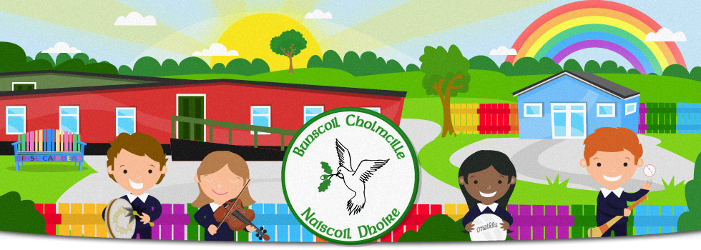

Ranganna Gaeilge /Irish classes

**Ar mhaith leat comhrá Gaeilge a bheith agat?**

Would you like to learn and be able to converse in Irish?

Well, our Irish class is beginning this coming

**Monday, 17 October from 7.30-9.00**

**and every Monday at the same time**

**in Bunscoil Cholmcille**

Bring a friend or two, the emphasis will be on conversation Irish.

Guarantee, you’ll be leaving on the first night with a ‘cúpla focal’ few words of Irish