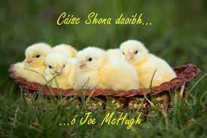

**40A Bóthar Bhaile Stíl,**

## Doire Cholmcille

**BT48 8EX**

**Guthán : (028) 7135 9648** Ríomhphost: [info@gaeloid.doire.ni.sch.uk](mailto:info@gaeloid.doire.ni.sch.uk)

## www.bunscoilcholmcille.com

## 3 Aibreán (04) 2023

## *SAOIRE NA CÁSCA /EASTER HOLIDAYS*

Cáisc Shona daoibh uilig / Happy Easter to you all

**Deireadh téarma / end of term**

* The children from Bunscoil Cholmcille will finish on ***Wednesday 5h April at 12.30 p.m.*** School meals will be available at 12.00. Please inform the class teacher if your child is going home at 12.00. The school taxis have been arranged for 12.30 p.m.
* Naíscoil Dhoire will finish at 12.00.
* Classes will resume on ***Monday 17th April 2023***

***Triú Téarma / Third Term***

Luan / Monday 17/4/23 – Aoine / Friday 30/6/23

School will be closed for children on the following dates;

Luan / Monday 1/05/23

Luan /Monday 8/05/23

Déardaoin / Thursday 18/05/23

Luan / Moday 29/05/23

Máirt / Tuesday 30/05/23

**Comhghairdeas / Congratulations**

Le foireann peil gaelach na scoile a d’imir thar barr in éadan scoileanna eile áitiúla ar na mallaibh.

To our gaelic football team who played exceptionally well in a blitz against other schools recently.

Le Lily & Ameilia as Rang 6 a mbeidh a ndánta foilsithe i ‘Rhyme and Reason.’

To Lily & Amelia from Rang 6 who took part in the Foyle Schools Poetry competition and who will have their poems published in a poetry book called ‘Rhyme & Reason.’

**Tréimhse Máithreachais**

**Maternity Leave**

Beidh Brónagh Halpenny, cuntóir i Rang 1 ag dul ar thréimshe máithreachais ón Chéadaoin seo. Guíonn muid gach rath uirthi.

Brónagh Halpenny, a classroom assistant in Rang 1 will be leaving this Wednesday to begin maternity leave. We wish Bronagh all the best as she awaits the arrival of her baby.

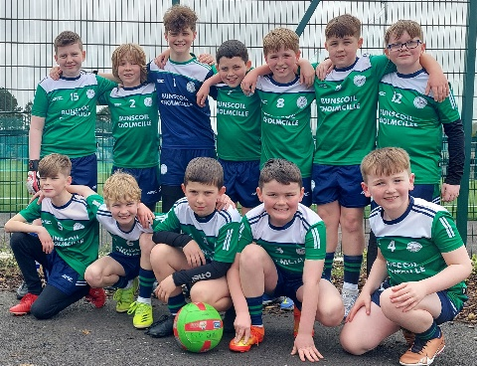

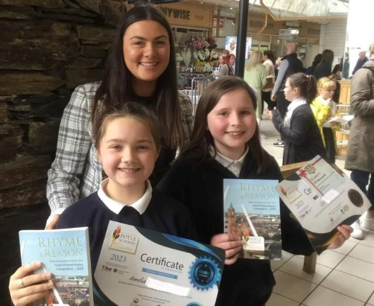

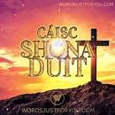

**Trócaire**

Buíochas ar son an airgid uilig a tháinig isteach do Thrócaire.

Thank you to everyone who filled the Trócaire boxes and a lot of them were filled! The children enjoyed ‘sabotaging’ each other’s boxes, but it was all for a good cause. £563.33 money was raised

Maith sibh.

**Dátaí Tábhachtacha / Important dates**

**26/04/23: Cóineartú / Confirmation**: Our lady of Lourdes, Steelstown

***27/04/23***: Naíscoil and Rang 1 places for September 2023 announced

***28/04/23***: Dress down Friday

***05/05/23***: Danceathon

***10-19/05/23:*** End of year tests (we ask that all children try to attend school so that tests can be completed as a whole class)

***20/05/23***: Post primary schools announced

***21/05/23***: **An Chéad Chomaoineach / First Communion** 12.30 in St. Josephs’s chapel, Galliagh

***26/05/23***: Lá gruaig ar mire/ Crazy hair day

***05/06/23***: Céimeanna Cholmcille / Colmcille’s Footsteps

***08/06/23***: Rang 7, Fan the Flame mass in Celtic Park

***14/06/23***: La Spóirt/Sports day

***23/06/23***: Lá Siamsaíochta/auction / Fun day/auction

***27/06/23***: Rang 7 ag críochnú/last day for Rang 7.

***30/06/23***: Leath lae 12.30/ Last day of term 12.30

Dates for end of year trips to be decided yet. Some of the above events are to raise money to help subsidise the cost of buses etc.

**Crannchur / Easter Raffle**

Thank you to everyone who bought tickets for the Easter raffle and congratulations to those who won prizes. All proceeds will be used to buy resources for classes especially the outdoors area.



***Stailc /Strike***

We have just been informed that the teaching unions are going on a full day strike on Wednesday, 26 April. This also happens to be the day Rang 7 will be receiving the sacrament of Confirmation. The Confirmation will go ahead as planned.

Garden Beds  
To ease the pressure off individual families with the upkeep of the beds, we have decided to rearrange them into bigger class beds. (This will be a gradual change, as it will take time to rebuild).  
Each class will focus on an individual crop, and these will be rotated yearly.  
Whilst each crop is growing, other classes will be invited to come and visit and learn about their stages of growth.  
The children can still decorate their class bed on various occasions. There will be, however, a strict ban on plastic. The children are encouraged to use natural materials only.  
The class beds will encourage teamwork and it will ensure no child is excluded.  
If any of our families are interested in helping out with the rebuild, get in touch with Múinteoir Róisín Rang 7.

***Cór na scoile / School Choir***

Beidh cór na scoile ag ceol ag an Chóineartú agus ag an Chéad Chomaoineach.

Tá sé iontach tábhachtach go bhfuil gach duine acu i láthair don dá ócáid speisialta seo.

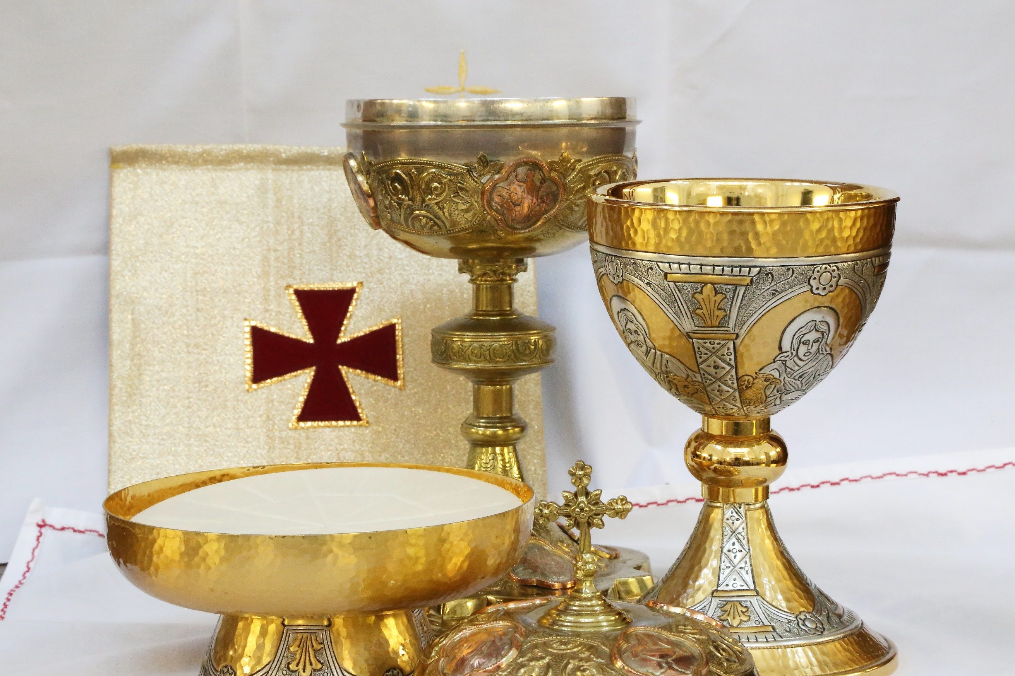

The school choir will be singing at the Confirmation mass on the 26 April and at the First Communion mass on the 21 May. It is very important that each member is present on the day as it adds greatly to the mass and makes it extra special for the children receiving the sacraments.