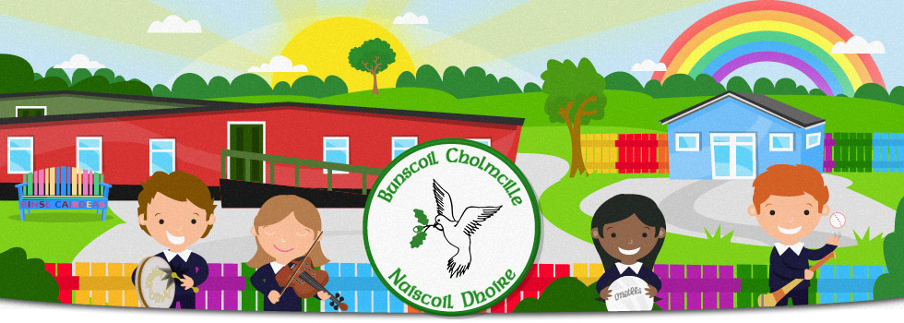

**Seirbhís Ceoil** 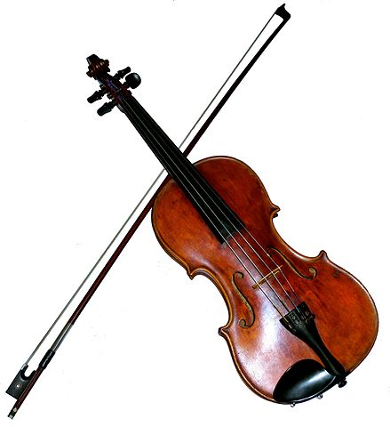

We received news yesterday evening that ‘Music Service tutors who teach strings, percussion and keyboard will resume face to face tuition in schools from the 19th April.. Pleasure ensure instrument and case are cleaned before brought into school.

Therefore, pupils in Rang 6/7 should bring their violins to school this coming Monday.

**Fáilte ar ais chuig téarma nua**

**Welcome back to a new term**

**Téarma na tSamhraidh / Summer Term**

**12/4/21-30/06/21**

School will be closed for pupils on:

03/05/21 & 04/05/21 31/05/21 & 01/06/21



**Biachlár/Canteen menu**

A new canteen menu was uploaded to the school website under ‘Tuismitheoirí’ yesterday. It provides a meal choice most days. Please ensure your child knows which meal they’re having each day.

**Sos**

A piece of fruit, cheese, water

The milk scheme will begin again shortly.

**Sláinte & Sábhailteacht/Health & Safety**

All parents/visitors should wear a mask at the school gate and on school grounds.

Please sanitise your hands when entering.

If your child is feeling unwell, he/she is to remain at home. Covid Symptoms: • Cough • Temperature • Loss of taste/ smell

Please, don’t send anything to school with your child that doesn’t need to be in. All that is needed is a healthy snack, a healthy lunch if they’re bringing their own and a warm coat. Please ensure that the lunch is nut free.

Class teachers will explain to their class about home works etc.

**A Reminder**

A close contact is: A person who has been close to a confirmed case from 2 days before the person was symptomatic to 10 days after the onset of symptoms and: • Lives in the same household • has travelled in a car with the case OR • has been within 2 metres of a case for more than 15 minutes OR • has been within 1 metre of a case and had face-to-face contact including: • being coughed on • having a face-to-face conversation • having skin-to-skin physical contact

**Clubanna iar-scoile / After school clubs**

We have been informed that after school clubs can begin again soon. We will be in contact when this is arranged.

**Bonus Ball**

We will begin our bonus ball again on Monday. Please send £10 in an envelope with your number(s) written clearly. (1-59)

£50 each week to the person who chooses the bonus ball from the Saturday lotto draw.



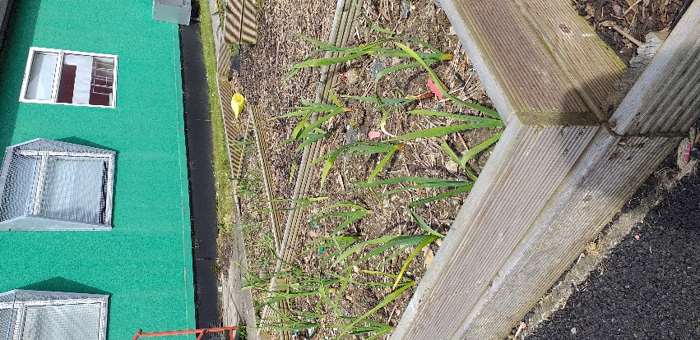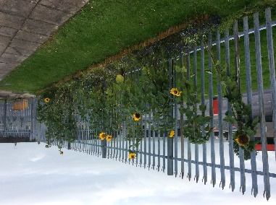

**Geodesic dome & an gairdín**

Our focus this year is to develop and make better use of our outdoor spaces for teaching and learning.

Our dome is now complete and will be used by us all for planting seeds, watching them grow etc.

Our garden is also in bloom and will be used every day by classes. We now have a literacy and numeracy shed, mud kitchens, the gazebo, a swing and benches. Our aim is to continue to develop this wonderful spot that we have.

Keep an eye on our website for photographs

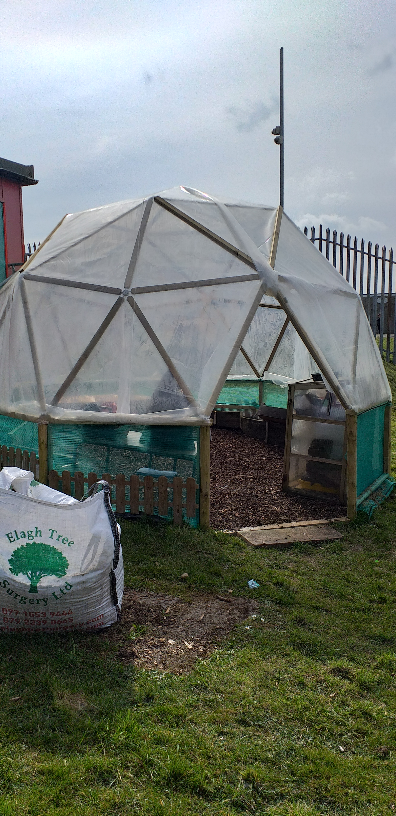

**Ag garraíodóireaocht / Gardening**

Have a look at our website to see how busy our pupils have been recently. They have planted potatoes, onions and garlic. We will soon be planting pumpkin seeds, sunflowers and other flowers as well. Well done everyone.

As you know, every family has their own raised bed so the children will be busy keeping an eye on those. Rang 2 will be constructing their beds on Wednesday at 1.00.

We may be looking for a helping hand soon to fill up our beds and a bit of general clean up around the school. We will be in contact soon about this.

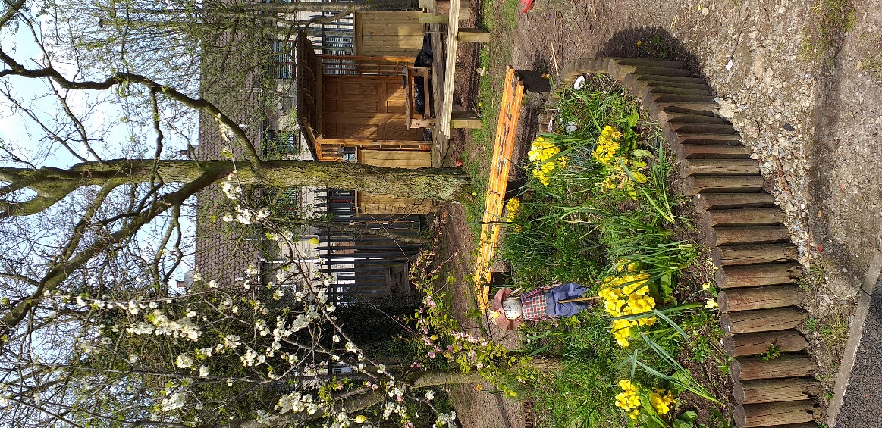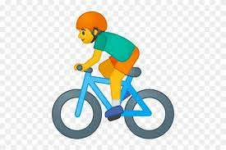

**Bí ag rothaíocht/Keep pedalling**

Get set… we’re taking part in Sustrans Big Pedal 2021, the UK’s largest inter-school cycling, walking, wheeling and scooting challenge. The challenge runs from **19 April to 30 April.** It’s free and we would love everyone to be involved.

**What do you need to do?**

Encourage your child(ren) to take active journeys to school on as many days as possible during the event, and join them on their way.