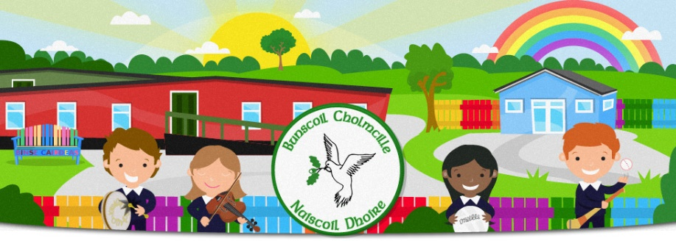
Lúnasa/August 2022
Bunscoil Cholmcille & Naíscoil Dhoire
40A Bóthar Bhaile Stíl
Doire
BT48 8EX
www.bunscoilcholmcille.com
infor@gaeloid.doire.ni.sch.uk
028 71359648
A Thuismitheoir/Choimeadaí, a chara,
Tá súil agam go raibh sos breá agaibh uilig, tá muid ag an phointe go bhfuil muid uilig ag pleanáil le bheith ag filleadh ar scoil.
I hope you all had a lovely break, we are at the point where we are all planning to return to school. We are all looking forward to seeing the children return on Thursday 1 September and we keep our fingers crossed that it will be a more settled school year than the previous few years have been.
Below are the teachers assigned to each class;
Naíscoil Dhoire: Múinteoir Nuala Bn. Mhic Giolla Bhuí
Rang 1: Múinteoir Clíona Nic Cionnaith
Rang 2: Múinteoir Niamh Ní Chearúil
Rang 3: Múinteoir Saoirse Ní Dhabóc
Rang 4: Múinteoir Aisling Ní Mhaolómhair
Rang 5: Múinteoir Niamh Nic Eochaidh
Rang 6: Múinteoir Erin Ní Shandair
Rang 6/7: Múinteoir Róisín Bn. Mhic Giolla Bhuí (Monday-Wednesday. Múinteoir Máire Bn. Mhic Lochlainn (Thursday-Friday)

Start and finish times
Naíscoil Dhoire: 8.55 – 1.25
Rang 1 and Rang 2: 8.55 – 2.00
Rang 3: 8.55 – 2.35
Rang 4-7: 8.55 – 2.50
We welcome our new pupils to Naíscoil Dhoire and Rang 1, they will begin on a staggered basis as is normal to allow them time to settle into school life.
The brother/sister club will continue for children in Rang 1 (when they begin the full day) and Rang 2 who have a sibling in an older class.

If you feel you may be entitled to free school meals and/or transport allowance, please apply if you haven’t already done so. Your child will have to bring a packed lunch or pay for dinner if his/her name is not on the list we receive from the Education Authority.
Your child can bring a healthy snack for break. We will begin the fruit and the milk scheme again soon.

After school clubs will not be beginning just yet. We will send word as soon as they are fully organised.

Is mise le meas
Máire Mhic Lochlainn.
Príomhoide

